# Hans Alberto Franke

## Date: 11/10/2020

## Assignment Spatial Data: Lab_1_1

## For the suitability assessment, you may need to consider following six factors:

* Greenness of the city (e.g., parks, trees, green areas)
* Land use types in the city
* Digital Elevation Map of the city
* Points of interest in the city (e.g, schools, shops, hospital, etc)
* Residential buildings in the city
* Street network in the city

Description:

* The source of the dataset (from where you downloaded the dataset)
* Download link (if available)
* A short description of the dataset content (what the dataset is about)
* A screenshot of QGIS visualization of the dataset
* Spatial metadata description that includes:
  + Number of dimensions (1D, 2D, 3D, 4D) in the dataset
  + Spatial representation type (e.g. raster, vector, text table) in the dataset
  + Coordinate Reference System(s) of the dataset

## DataSet1:

|  |  |
| --- | --- |
| Map layer | MONUMENTAL_TREES |
| Page link | https://maps.amsterdam.nl/open_geodata/?k=59 |
| Attributes | Tree species Scientific_name Plant year Stem circumference Stem diameter Conservation value Explanation Reference number_town part Sequence number Group SELECTION_CAT Photo Determined Background |
| Number of objects | 2615 |
| Topicality | August 2015 |
| Read the Explanation | [**https://maps.amsterdam.nl/monumentaal_groen/>**](https://maps.amsterdam.nl/monumentaal_groen/?LANG=nl) |
| Additional explanation |  |
| Source holder | Municipality of Amsterdam - Monuments and Archeology |
| Contact | Paul Nieuwenhuizen |
| E-mail | paul.nieuwenhuizen@amsterdam.nl |

Description:

Dataset with green monuments and distribution of tree around the city

### Screenshot:

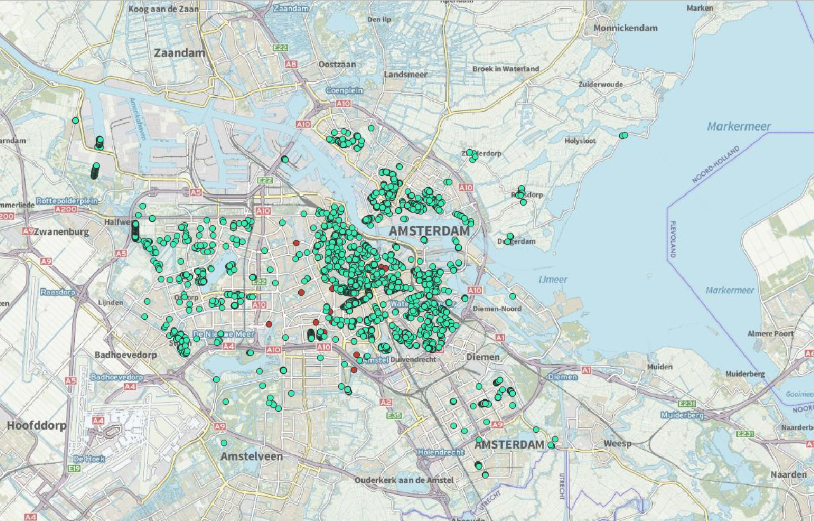

### Metadata:

Dimensions: 2D

Representation: Vector

Coordinates: EPSG:4326 | WGS84.

## DataSet2:

### Description:

The Land Use File 2015 contains digital geometry of land use in the Netherlands. Examples of land use are traffic areas, buildings, recreation areas and indoor and outdoor water. The boundaries are largely based on the Top10NL (BRT). Aerial photographs are leading when interpreting. The data was collected in the summer of 2015.

### Information Table:

|  |  |
| --- | --- |
| **Type** | wfs |
| **URL** | [https://geodata.nisjes&service=WFS](https://geodata.nationaalgeoregister.nl/bestandbodemgebruik2015/wfs?&request=GetCapabilities&service=WFS) |
| **Metadata Service** | [View the metadata](https://www.nationaalgeoregister.nl/geonetwork/srv/dut/catalog.search#/metadata/25a99d92-ea8a-4163-82ab-3521c9b0c96b) |
| **Metadata Data** | [View the metadata](https://www.nationaalgeoregister.nl/geonetwork/srv/dut/catalog.search#/metadata/2d3dd6d2-2d2b-4b5f-9e30-86e19ed77a56) |

### Screenshot:

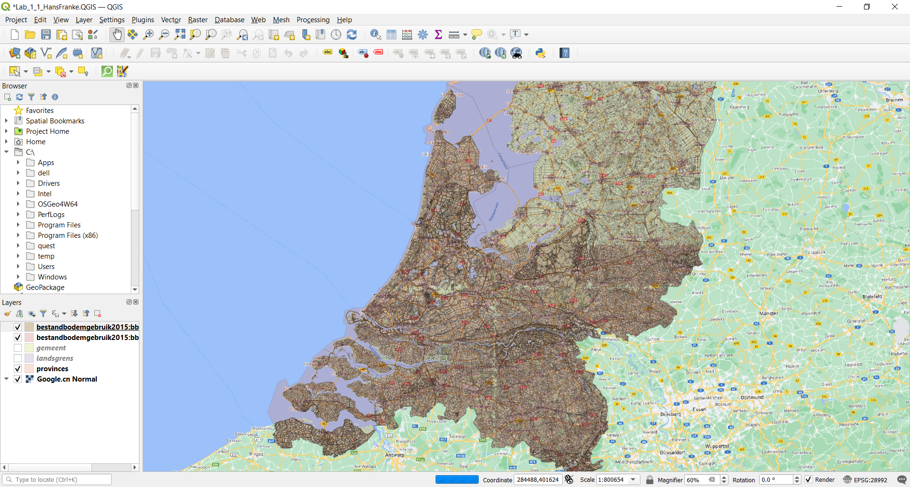

### Metadata:

### Dimensions: 2D

### Representation: VECTOR

### Coordinates: EPSG:28992 / Amersfoort / RD NEW

## Dataset3:

### Description:

Areas of barbecue in Amsterdam 😊

### Information Table:

|  |
| --- |
|  |
| Map layer | BBQ |
| Page link | https://maps.amsterdam.nl/open_geodata/?k=319 |
| Attributes | Name |
| Number of objects | 38 |
| Topicality | Regularly updated |
| Read the Explanation | [**https://maps.amsterdam.nl/bbq/>**](https://maps.amsterdam.nl/bbq/?LANG=nl) |
| Additional explanation |  |
| Source holder | Municipality of Amsterdam - Space and Sustainability |
| Contact |  |
| E-mail |  |

### Screenshot:

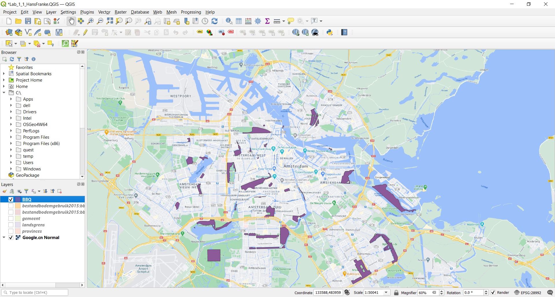

### Metadata:

### Dimensions: 2D

### Representation: Vector

### Coordinates: EPSG:4386 WG84